**ABOUT DEPARTMENT OF ATOMIC ENERGY (DAE)**

The Department of Atomic Energy (DAE) was set-up on August 3, 1954 under the direct charge of the Prime Minister. The vision of the DAE is to empower India through technology, creation of more wealth and providing better quality of life to its citizen. This is to be achieved by making India energy independent, contributing to provision of sufficient, safe and nutritious food and better health care to our people through development and deployment of nuclear and radiation technologies and their applications.

DAE is engaged in the design, construction and operation of nuclear power/research reactors and the supporting nuclear fuel cycle technologies covering exploration, mining and processing of nuclear minerals, production of heavy water, nuclear fuel fabrication, fuel reprocessing and nuclear waste management. It is also developing advanced technologies that contribute to the national prosperity. The spin-off technologies, human resource developed and technical services being rendered by the Department have been greatly helping the Indian industry. It is also developing better crop varieties, techniques for control/eradication of insects thus protecting the crops, radiation based post harvest technologies, radiation based techniques for diagnosis and therapy of disease particularly cancer, technologies for safe drinking water, better environment and robust industry.

Main Focus areas of work in DAE are:

1. Increasing share of nuclear power through deployment of indigenous and other proven technologies, along with development of fast breeder reactors and thorium reactors with associated fuel cycle facilities.
2. Building and operation of research reactors for production of radioisotopes and carrying out radiation technology applications in the field of medicine, agriculture and industry.
3. Developing advanced technologies such as accelerators, lasers, supercomputers, advanced materials and instrumentation, and encouraging transfer of technology to industry.
4. Support to basic research in nuclear energy and related frontier areas of science, interaction with universities and academic institutions, support to research and development projects having a bearing in DAE’s programmes and international co-operation in related advanced areas of research and
5. Contribution to national security.

DAE has made the following significant contributions of DAE to the national initiatives:

1. **AGRICULTURE:** Enhanced production of oilseeds and pulses
2. **EDUCATION, HEALTH:**
   1. Homi Bhabha National Institute (HBNI)
   2. National Initiative on Undergraduate Science (NIUS)
   3. Countrywide Services in Cancer through Telemedicine
3. **FOOD & NUTRITION SECURITY:** Radiation Processing of Food & Agro Products.
4. **WATER RESOURCES:** Desalination in water scarcity areas along the sea coast.
5. **ENERGY SECURITY:** Electricity supply in near and long term ensuring long term sustainable development.

DAE has been constantly striving for the development of the nation by its miscellaneous researches in the field of radiation. This prolific institution has always supported the country as a part of its backbone and gave its mechanical balance to the country’s growth.

There are still many researches going on under this mammoth organisation for the development of many areas like medical research, power generation, agriculture, military, etc., such kind of researches have been taken up by this organisation for making the country whose needs are self sufficient.

DAE hopes that such kind of beneficial researches shall always be taken up for the betterment of the country and prove our country to be the best among all other countries in the world by making to reach the country towards a pinnacle mark of success and prosperity.

Departments under DAE:-

* [Tata Institute of Fundamental Research](http://www.tifr.res.in/)
* Bhabha Atomic Research Centre
* [Saha Institute of Nuclear Physics](http://www.saha.ac.in/)
* [Tata Memorial Centre](http://tmc.gov.in)
* [Harish-Chandra Research Institute](http://www.hri.res.in/)
* [Institute of Physics](http://www.iopb.res.in/)
* [National Institute of Science Education and Research](http://www.niser.ac.in/)
* [Institute of Mathematical Sciences](http://www.imsc.res.in/)
* [Institute for Plasma Research](http://www.ipr.res.in/)
* [Board of Research in Nuclear Sciences (BRNS)](http://www.barc.gov.in/brns/index.html)
* [National Board for Higher Mathematics (NBHM)](http://www.nbhm.dae.gov.in/)
* [Atomic Energy Education Society](http://www.aees.gov.in/)
* [Homi Bhabha National Institute](http://www.hbni.ac.in/)
* [Nuclear Power Corporation of India Ltd](http://www.npcil.nic.in/)
* **Nuclear Fuel Complex**
* Heavy Water Board
* Board of Radiation and Isotope Technology
* Indira Gandhi Centre for Atomic Research
* Raja Ramanna Centre for Advanced Technology
* Variable Energy Cyclotron Centre
* Atomic Minerals Department
* Global Centre for Nuclear Energy Partnership
* [Bharatiya Nabhikiya Vidyut Nigam Ltd](http://www.bhavini.nic.in/)
* [Uranium Corporation of India Ltd](http://www.ucil.gov.in/)
* [Indian Rare Earths Ltd](http://www.irel.gov.in/)
* [Directorate of Construction & Estate Management](http://www.dcsem.gov.in/)
* [Directorate of Purchase and Stores](http://www.dpsdae.gov.in/)
* [General Services Organisation (GSO), Kalpakkam](http://www.igcar.ernet.in/gso/)

**HOW A NUCLEAR REACTOR GENERATES ELECTRICITY**

A nuclear reactor produces and controls the release of energy from splitting the atoms of uranium.

Uranium-fuelled nuclear power is a clean and efficient way of boiling water to make steam which drives turbine generators. Except for the reactor itself, a nuclear power station works like most coal or gas-fired power stations.

**The Reactor Core**

Several hundred fuel assemblies containing thousands of small pellets of ceramic uranium oxide fuel make up the core of a reactor.  For a reactor with an output of 1000 megawatts (MW), the core would contain about 75 tonnes of enriched uranium.

In the reactor core the U-235 isotope fissions or splits, producing a lot of heat in a continuous process called a chain reaction.  The process depends on the presence of a moderator such as water or graphite, and is fully controlled.

The moderator slows down the neutrons produced by fission of the uranium nuclei so that they go on to produce more fissions.

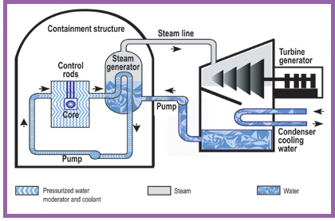Some of the U-238 in the reactor core is turned into plutonium and about half of this is also fissioned similarly, providing about one third of the reactor's energy output. The fission products remain in the ceramic fuel and undergo radioactive decay, releasing a bit more heat.  They are the main wastes from the process. The reactor core sits inside a steel pressure vessel, so that water around it remains liquid even at the operating temperature of over 320°C.  Steam is formed either above the reactor core or in separate pressure vessels, and this drives the turbine to produce electricity.  The steam is then condensed and the water recycled.

**INDIA’S 3 STAGE NUCLEAR POWER PROGRAMME**

India's three-stage nuclear power programme was formulated by Dr. [Homi Bhabha](http://en.wikipedia.org/wiki/Homi_Bhabha) in the 1950s to secure the country’s long term energy independence, through the use of [uranium](http://en.wikipedia.org/wiki/Uranium) and [thorium](http://en.wikipedia.org/wiki/Thorium) reserves found in the [monazite](http://en.wikipedia.org/wiki/Monazite) sands of coastal regions of [South India](http://en.wikipedia.org/wiki/South_India). The ultimate focus of the programme is on enabling the thorium reserves of India to be utilised in meeting the country's energy requirements. Thorium is particularly attractive for India, as it has only around 1–2% of the global [uranium reserves](http://en.wikipedia.org/wiki/List_of_countries_by_uranium_reserves), but one of the largest shares of global [thorium reserves](http://en.wikipedia.org/wiki/Thorium#American_Assessment) at about 25% of the world's known thorium reserves.

The country published about twice the number of papers on thorium as its nearest competitors, during each of the years from 2002 to 2006. The Indian nuclear establishment estimates that the country could produce 500 GWe for at least four centuries using just the country’s economically extractable thorium reserves.

As of 2012, the first stage consisting of the [pressurised heavy water reactors](http://en.wikipedia.org/wiki/Pressurised_heavy_water_reactor) (PHWR) is near completion of its planned goals, the second stage consisting of [fast breeder reactors](http://en.wikipedia.org/wiki/Breeder_reactor) (FBR) is poised to go into operation within one year, and the third stage consisting of [advanced heavy water reactors](http://en.wikipedia.org/wiki/Advanced_heavy_water_reactor) (AHWR), as one among several technology options, is slated to begin construction so that its commissioning can be done by 2020. The recent [Indo-US Nuclear Deal](http://en.wikipedia.org/wiki/U.S.-India_Civil_Nuclear_Agreement) and the [NSG](http://en.wikipedia.org/wiki/Nuclear_Suppliers_Group) waiver, which ended more than three decades of international isolation of the Indian civil nuclear programme, have created many hitherto unexplored alternatives for the success of the three-stage nuclear power programme.

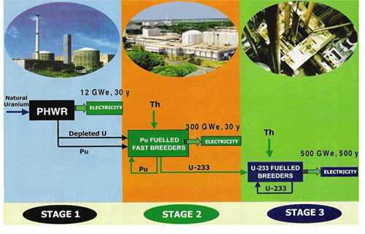

**ABOUT NUCLEAR FUEL COMPLEX (NFC)**

The ***Nuclear Fuel Complex*** (NFC) was established in 1971 as a major industrial unit of [Department of Atomic Energy](http://en.wikipedia.org/wiki/Department_of_Atomic_Energy_%28India%29), for the supply of [nuclear fuel](http://en.wikipedia.org/wiki/Nuclear_fuel) bundles and [reactor](http://en.wikipedia.org/wiki/Nuclear_reactor) core components. It is a unique facility where natural and [enriched uranium](http://en.wikipedia.org/wiki/Enriched_uranium) fuel, [zirconium](http://en.wikipedia.org/wiki/Zirconium) alloy cladding and reactor core components are manufactured under one roof. NFC symbolizes the strong emphasis on self-reliance in the Indian Nuclear Power Programme.

Zirconium ore is obtained from the beach sands of Kerala and Tamilnadu. Natural [uranium](http://en.wikipedia.org/wiki/Uranium), mined at [Jaduguda Uranium mine](http://en.wikipedia.org/wiki/Jaduguda_Uranium_Mine) in the [Singhbhum](http://en.wikipedia.org/wiki/Singhbhum) area in the state of [Jharkhand](http://en.wikipedia.org/wiki/Jharkhand), both are converted into nuclear fuel assemblies over here.

Functions and achievements of NFC include:-

* Plans to establish two major fuel fabrication facilities to meet the expected jump in nuclear power production.
* Doubled the capacity and delivered the fuel for all the new and operating reactors of NPCIL, with a sound and comprehensive quality management system, the fuel performance in the reactors has been found to be comparable to international standards with a very low fuel failure rates.
* Fabricates core sub assembles and components for the LMFBR programme including the operating fast breeder test reactor and the forthcoming prototype FBR.
* Manufactures seamless stainless steel and special alloy tubes, high purity and advanced materials for various hi – tech applications in atomic energy, defence, space and other industries, zirconium alloy components for non nuclear applications in fertilisers and heavy chemical industries.
* Implemented sound occupational health, safety and environment management system. The green environment of the premises testify the eco- friendly plant operations as a benevolent employer, NFC provides housing assistance, Medicare and educational facilities to all employees and their families.
* Accredited with ISO 9001, ISO 14001 and OHSAS 18001 certification and strengthening corporate R&D, poised to meet the future requirements of the nuclear power programme.

**MATERIAL FLOW PROCESS IN NFC**

There are majorly two types of materials in NFC which are Zirconium and Uranium these follow typical steps of processes to obtain desired materials.

Flow of Zirconium:-

Flow of Uranium:-

**SPECIAL TUBE PLANT (STP)**

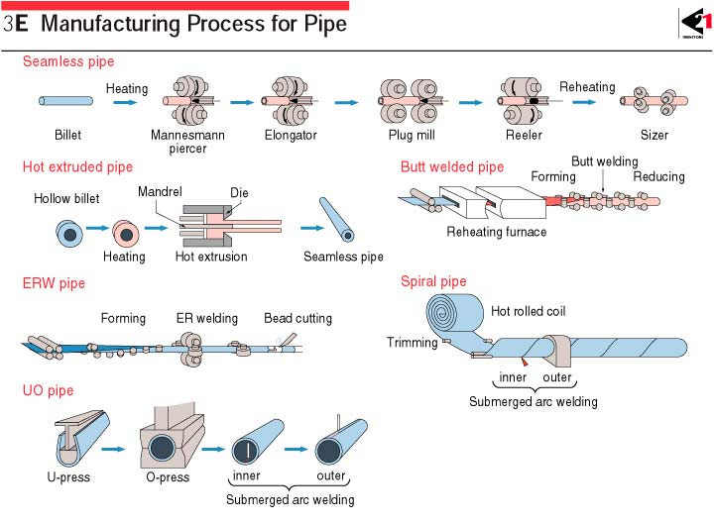Tubes can be manufactured by various processes as shown below:-

The special tube plant in NFC reprocesses the hot extruded tubes to final dimension by the process of pilgering.

There are many ways of manufacturing the tubes as shown above but, NFC uses extrusion process also known as double radial forging for the manufacturing of Zircalloy tubes which comprise calandria, coolant, fuel tubes, etc., the extruded tubes due to hot working may not come with exact dimensions and properties as required so, the tubes are further processed to achieve the exact dimensions and required properties.

The pilgering process takes place in this Special Tube Plant of NFC. Other machining processes like honing, grinding, annealing, etc., for the tube also take place in this plant itself.

**PROPERTIES OF ZIRCONIUM & PROCESS FLOW OF TUBES IN STP**

Zircalloy tubes are used in nuclear reactors as coolant tubes, calandria, fuel tubes, etc., zirconium being less absorbent to neutrons gives the advantage of smooth functioning of nuclear reactor by providing maximum fissions. Coolant tubes are made of Zr–Nb 2.5 zirconium alloy which consists of 2.5% Niobium in Zirconium with some other alloying elements. Calandria tubes are made of zircalloy 4 which consists of alloying elements like tin, iron, chromium, etc., in it. The whole structure of the fuel assembly is as shown in the figure below:-

 The calandria is the whole support for the reactor, the pressure or coolant tube fits inside the calandria housing the fuel bundles for the nuclear fission reaction. The spacers provide thermal insulation between the calandria and the pressure tubes. Generally, the pressure tubes are separated by a Garter spring system. Proper insulation is required to monitor the temperature of the core to a certain level required.

Different kinds of zirconium alloys can be used for different purposes depending on the nature of their mechanical properties. Since, different alloys have different practical uses on the nature of their alloying elements present in them similarly; the zirconium alloys also have their wide range of uses respectively.

Various other alloys of zirconium and their respective uses are as follows:-

|  |  |  |  |  |
| --- | --- | --- | --- | --- |
| **Alloy** | **Sn%** | **Nb%** | **Component** | **Reactor type** |
| Zircaloy 2 | 1.2–1.7 | – | Cladding, structural components | [BWR](http://en.wikipedia.org/wiki/Boiling_water_reactor), [CANDU](http://en.wikipedia.org/wiki/CANDU_reactor) |
| Zircaloy 4 | 1.2–1.7 | – | Cladding, structural components | [BWR](http://en.wikipedia.org/wiki/Boiling_water_reactor), [PWR](http://en.wikipedia.org/wiki/Pressurized_water_reactor), [CANDU](http://en.wikipedia.org/wiki/CANDU_reactor) |
| ZIRLO | 0.7–1 | 1 | Cladding | [PWR](http://en.wikipedia.org/wiki/Pressurized_water_reactor) |
| ZrSn | 0.25 | – | Cladding | [BWR](http://en.wikipedia.org/wiki/Boiling_water_reactor) |
| Zr2.5Nb | – | 2.4–2.8 | Pressure tube | [CANDU](http://en.wikipedia.org/wiki/CANDU_reactor) |
| E110 | – | 0.9–1.1 | Cladding | [VVER](http://en.wikipedia.org/wiki/WWER) |
| E125 | – | 2.5 | Pressure tube | RBMK |
| E635 | 0.8–1.3 | 0.8–1 | Structural components | VVER |
| M5 | – | 0.8–1.2 | Cladding, structural components | [PWR](http://en.wikipedia.org/wiki/Pressurized_water_reactor) |

Abbreviations:-

ZIRLO: - ZIRconium Low Oxidation.

BWR: - Boiling Water Reactor

PWR: - Pressurised Water Reactor

CANDU: - CANada Deuterium Uranium (Canadian)

VVER: - Vodo Vodyanoi Energetichesky Reaktor (Russian)

RBMK: - Reaktor Bolshoy Moshchnosti Kanalnyy (Russian)

The general properties of Zirconium are as follows:-

Mass density – 6530 kg/m3

Melting point – 1853 oC

Tensile strength (Annealed) – 330 MPa

Yield strength – 230 MPa

Young’s modulus – 94.5 GPa

Poisson’s ratio – 0.34

Elongation – 32%

Brinells Hardness – 145

Rockwell A Hardness – 49

Rockwell B Hardness – 78

Vickers Hardness – 150

Coefficient of linear expansion ‘’ – 5.8 m/moC

Thermal conductivity – 16.7 W/mK

Zirconium exhibits high pyrogerric properties i.e., it can easily catch fire when in powder form. Water shouldn’t be used to extinguish as it can cause more fire, **only Type D fire extinguishers should be used like dry table salt.** A special chemical called TEC (Ternary Eutectic Chloride) for metal fires can be used.

The STP plant in NFC processes both calandria and pressure tubes after the extrusion process of them being done in the Extrusion plant. The tubes are generally processed to their final dimensions by the process of pilgering but, before the tubes are pilgered the tubes have to be processed initially to some physical conditions so that it can be easily pilgered.

**PROJECT STATEMENT**

NFC’s STP has an existing layout for the manufacturing of coolant tubes and other tubes which are required for the nuclear reactors as hardware components. The third stage of India’s nuclear power programme corresponds to Advanced Heavy Water Reactors (AHWRs) which is similar to the Pressurized Heavy Water Reactor (PHWR) but, the fuels used are different. The plant has the capacity to produce 300-500 MWe power for approximately 500 years with the fissile products obtained from the second stage of India’s nuclear power programme which is Fast Breeder Reactor (FBR) as its fuel.

India is about to come to this stage for which it needs separate hardware materials for the specially designed AHWR reactors which houses the special fuel bundle assemblies.

NFC is planning to build a separate section for the production of AHWR tubes which is very near to the existing STP so that, by pooling the machinery resources available in STP, the tubes can be handled easily from upcoming section to the existing plant by which, the manufacturing of tubes can run smoothly with low budget and best place management allotted for the AHWR production space.

AHWR tubes have different dimensions but, the process of manufacturing follows the similar style as that of the PHWR tubes, there can be minor changes in route of the process but the major processes of manufacturing of the tube remain the same.

**“**The project assigned to our team of students was to analyze the existing route of manufacturing of PHWR tubes in STP’s machinery plant layout and design a better machinery arrangement for the upcoming AHWR plant so that the tube travels minimum length of manufacturing cycle with the given machineries in the upcoming plant thus, saving time and extra distance of travel by tube**”**.

This is the assignment which was to be completed within the given amount of time and the best layout was to be submitted to NFC–STP office for their consideration of the plant’s machinery arrangement according to their convenience and adopt the suitable plan which suits their requirement exactly to their need.

**STUDY OF EXISTING PLANT LAYOUT**

There are various methods for studying the layout of a given plant, the technique followed in this report is relative positioning technique where, the machines’ layout is made on the basis of selecting suitable position of a machine or shed or other objects like pillars, etc.,

This is done instead of adopting dimensions because no classified information is to be mentioned in the report regarding machines or other components in the factory.

STP has cranes for lifting loads like tubes, machine components, etc., placed on the top, on the roof which is supported by a bridge pillars which are like trusses. These truss pillars are placed at a suitable distance from each other in leftward and rightward directions by design. The machines are placed on the shop floor at suitable distance from the truss pillars which is the basis for the denoting the location of them used in this report.

All the machines are said here in terms of one, two or three pillar units, which means the length is specified by the distance between two **truss pillars** as fundamental unit of length which is continued in the whole report.

The layout can be now easily prepared by making the grid of the plant in terms of the **truss pillar unit** and placing the machines in the grid according to the position in the plant.

To make a grid we can use tables in MS Word, draw in Bitmap image, etc., the method followed in the report is by using MS Excel where the cells’ size can be manipulated according to the use required. The procedure is as follows:-

* Selecting the grid unit in terms of area i.e., the single unit’s width and height in terms of the truss pillar length. Here, nine unit cells (3*3) in Excel are taken as the unit area (square) which indicates one truss pillar unit width and height.
* Making the grid of the STP area in terms of this one unit square area and discretizing each unit with suitable borders to denote one unit area of the grid.
* Placing the machines according to the dimensions and to the position of truss pillars in the grid in STP.
* Separate colour coding or description of machines in abbreviated form to represent each one of them in terms of machining, testing or production of product.
* Indicating the passages by which the tube can travel or shift from one bay to the other.
* A note has to be made for the repetitive processes, time consuming processes and crucial processes for further consideration on designing the layout.

Once the grid layout of plant is prepared the tube traversing length can be calculated by counting the number of cells the tube covers in its path from one place to other. This is interpreted in terms of truss pillar units to convey the total length of tube travelled actually.

To make a layout, we should know about the processes involved in the manufacturing of tube which will be discussed in the next section.

The same process steps have been followed here and the gird of STP area in Excel is shown in the figure 1.

**MACHINE OPERATIONS ANDINSTRUMENTS IN STP**

Only those machines and instruments which are required for the study of plant layout and mainly involved in tube manufacturing are mentioned here.

1. 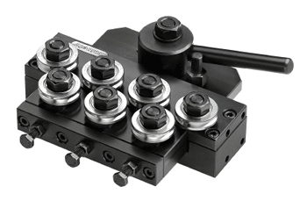**Roller straightening:** -This is used to straighten the deflected tube. It consists of hyperboloid shape like rollers which exert pressure on the tube’s deflections and deforms the tube to make it straight.(fig 1)
2. 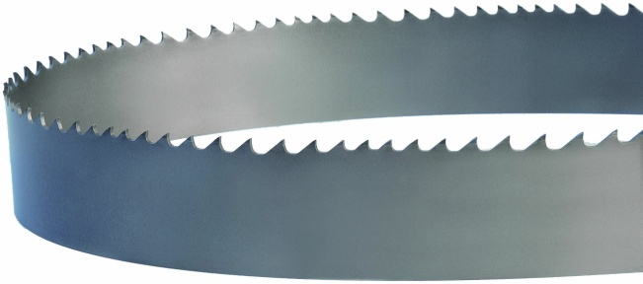**End cutting machine:** - This is a motor driven band saw type of cutting machine which is used to cut the ends of the tube.(fig 2)
3. 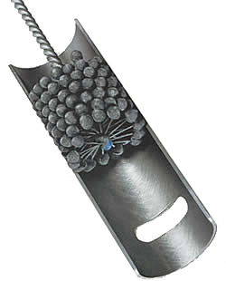**Honing:** - Machining process which increases the internal diameter of the tube by ID (Inner Diameter) surface grinding operation. The honing head is wrapped with specific grade of emery paper to carry out this process and coolant is pumped on the paper to protect the tube from overheating and avoiding the machined particles of Zirconium to catch fire by friction.(fig 3)
4. **Internal Diameter Polishing (ID Polishing):** - Similar to honing but, the machining rate compared to honing is less and smooth surface is ensured on the ID.(fig 4)

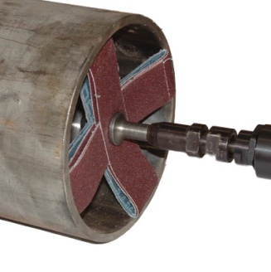

1. **Outer diameter grinding (OD grinding):** - Similar to honing but done externally on the surface of the tube. An emery paper rolls horizontally between two centers, this band is brought in contact with the tube and the grinding is carried out. Depending on the grade of emery paper, it is classified as grinding or polishing.(fig 5)
2. **Grinding wheel and pneumatic roller:** - Grinding wheel is simply a disc with grinding material vitrified to it to perform the operations of OD conditioning, which means correcting defects on the surface of the tube. The rotating disc is brought to contact on the required surface of the tube and machining is done accordingly.

Pneumatic roller contains the abrasive material like silicon carbide or alumina on its surface and it is driven by pneumatic force which rotates the roller. This is used to clear the defects on the internal surface of the tube. The roller is fixed to one of the ends on a long tube through which compressed air is sent.

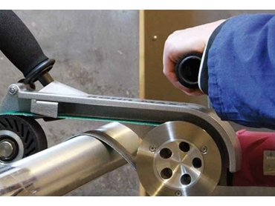

1. 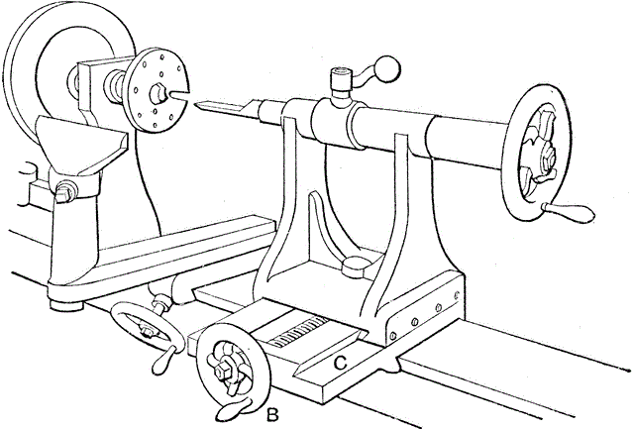**Lathe:** - There are certain end tube area operations like facing and polishing which is done on the lathe using a polishing tool.(fig 6)
2. **ID sandblasting:** - A stream of abrasive material under pressure is shot on the internal surface of the tube which brings a uniform surface removing pits and other minor defects.
3. 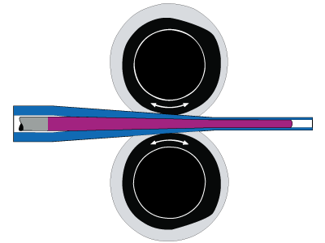**Pilgering:** - Longitudinal tube rolling process where the diameter and wall thickness of the tube is reduced simultaneously. It’s a cold working type here, to ensure the tolerance of dimensions across the tube.(fig 7)
4. **Alkali degreasing:** - When honing and pilgering of the tube is done, lot of grease and dirt is present inside and outside of the tube due to lubrication and cooling, this makes problem when the tube is fixed on other machines for machining operation so, it is given an alkali bath with a mixture of solutions like
5. **Autoclaving:** - Steam is used in this process by which, the tube is annealed and a coat of Zirconium oxide is formed on its surface to protect it from corrosion. As steam is used, the process is known as autoclaving.
6. **Quality check tests and equipment :-**

* **Ultrasound testing:** - Ultrasound test is based on the reflective nature of sound, when it strikes a uniform surface it strikes back again with same length but, in case of any defects like pits or non-uniformity, the length changes which is represented as a defect on a CRT screen. Probes are used here for transmitting the sound waves.(fig8)
* **Eddy current testing:** - A coil of copper winding enclosed in a cylindrical plastic container carries current which creates magnetic flux around it. When it is inserted inside the tube which is electrically conductive and magnetically permeable, it creates eddy currents on the internal surface of the tube, any defects like pits or scratches, the eddy current gets obstructed and the magnetic field of the copper coil changes this defect is seen on the computer screen as a variation of intensity. Used for detecting 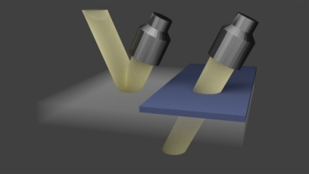minute defects on the inner diameter of tubes.(fig 9)

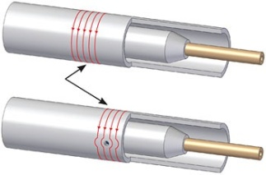

* 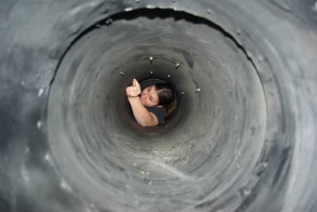**Boroscopy:** - It’s a process of examining the internal surface of the tube with the help of a concave mirror and light arrangement attached to a long stick to facilitate inward and outward motion inside the tube.(fig 10)
* **Pressure testing:** - High pressure of air is sent inside the tube to check its level of deformation i.e., if the tube is not able to withstand the pressure and any permanent deformation takes place, the tube gets rejected.

1. **High Wall Correction (HWC) and High Wall Band Correction (HBWC):** - Consider that the limits of tube wall are 25 +0.5 mm i.e., upper limit is 25.5 mm and lower limit is 25 mm if we have a tube whose variation of wall thickness is from 25.8 to 25.4 across its diameter then we have the freedom of machining the tube up to 0.3 mm across the diameter then the final dimension variation would be 25.5 mm maximum and 25.1 mm minimum which are under the limits of the wall and tube can be accepted this is known as High Wall Correction (HWC).

Again consider a tube whose variation of wall thickness is from 25.7 to 25 mm as mentioned above. Now, if we machine 0.2 mm across the diameter then the final dimension variation would be 25.5 mm maximum and 24.8 mm minimum, here, 24.8 is out of the limit and the tube cannot be accepted, to avoid this, the area of variation upto which machining under limit is possible is marked and by manually the tube is grinded on the OD grinding machine, this is known as High Wall Band Correction (HWBC).

1. **Measuring equipment:** -

* **Length of tube:** - Measuring tape.
* **Outer Diameter:** -  Pi) tape, Vernier calipers, etc.,
* **Inner Diameter:** - Bore gauge, etc.,
* **Surface roughness:** - Skid stylus.
* **Dimensional tolerances:** - Snap gauges and ovality snap gauges.

**Bend tolerances:** - Dial test indicator and bow foot.

**MANUFACTURING OF TUBES IN STP**

The coolant tube manufacturing process requires a special care because, the tubes are reactor grade and slight error in quality can cause vital changes in reactor and can interrupt the nuclear reaction which is not acceptable. Processes are too long to be displayed as a flow chart for which steps are written instead of it. The process of tube production goes as following:-

1. Extrusion Dejacketing

A layer of copper jacket is introduced on the surface of the zirconium billet to provide lubrication and resistance against corrosion which is dejacketed using pickling (nitric acid).

1. Dejacketing Roller Straightening

The extruded tube is not perfectly straight and has many deflections across its length which is undesirable for which it is straightened under low pressure and low deflection because there are residual stresses on the tube and high pressure can break it.

1. Roller Straightening End Cutting Machine

However, there is a part of ovality present at the ends of the tube, which can interfere in machining processes like honing and OD grinding for which, the ends are cut using the end cutting machine till allowable tolerance is maintained.

1. End Cutting Machine Degreasing

The tube contains grit and other dirt particles from extrusion and end cutting which should be removed immediately for which, it is given a degreasing bath with alkali solution.

1. Degreasing Annealing

The residual stresses from hot work have to be relieved for facilitating pilgering of the tube for which, the tube undergoes stress relieving annealing process which makes the tube ductile and low strength is maintained.

1. Annealing ID conditioning

There are crests developed on the internal diameter of the tube due to extrusion which are grinded off by a pneumatic grinder roller head which has SiC or Alumina on its surface.

1. ID conditioning Roller Straightening

Due to the self-weight of material and other reasons, the tube gets minor deflections across its length for which it has to be straightened again.

1. Roller Straightening Honing

The machining processes on whole tube starts from here where, the tube’s ID is increased by honing which is done across the whole length of the tube, this ensures utmost uniformity of ID, coolant is also added on emery paper to ensure cooling. The process is done for four times, changing the grade of emery paper contiguously to remove material in every pass.

1. Honing Degreasing

The coolant has to be cleaned from the tube which can be only done by an alkali degreasing bath to avoid untidiness while fixing to other machines.

1. Degreasing OD Grinding

The tube’s outer surface is also grinded off to remove the irregularities like pits, troughs, etc., similar to honing but done externally which reduces the OD.

1. OD Grinding Quality Check

After all the machining processes are completed on the tube, quality checks are performed to ensure whether the tube is under standards. This includes, checking the dimensions of the tube like length, OD, ID, wall thickness, etc., this confirms that the tube manufactured follows the quality regulations.

1. Quality Check Ultrasound Testing

Defects at each and every point can be found by this test which is noted at the distance from the leading edge and highlighted with a marker pen at that area.

1. Ultrasound Testing OD Conditioning

According to the test results of Ultrasound, the areas of re-correction are conditioned on OD using a grinding wheel and the defects are brought to uniformity by a polish finishing.

1. OD Conditioning ID Conditioning

Similar to the OD conditioning, the defects on ID can be corrected by honing or ID polishing machine as required and the surface of ID is brought to uniformity by a polish finishing here as well.

1. ID Conditioning Ultrasound Testing

The tube has to be checked for its defects again so it is tested under Ultrasound and the cycle from 12-14 repeats until defects stated by Ultrasound are nullified.

1. Ultrasound Testing Pilgering

Once there are no defects across the tube, it can go for the cold pilgering process where, the OD and wall thickness of the tube are reduced simultaneously, to the required dimensions. Pilgering of PHWR tubes generally follows only one pass.

1. Pilgering Degreasing

Tube is full of lubricated oil when it comes out of pilgering so, it is given an alkali degreasing bath for maintaining tidiness.

1. Degreasing Roller Straightening

The process of pilgering can create small deflections on tube for which, the tube is straightened using the roller straightener used before.

1. Roller Straightening End Cutting Machine

As seen before, both the ends possess some part of ovality which causes trouble for machining processes and are cut to the required length till the ovality is under allowable value which is done by end cutting machine.

1. End Cutting Machine Honing

Again the process of machining continues for this pilgered tube, honing is done again for four times by contiguously changing the grade of emery papers so that metal is removed accordingly and required dimension is obtained.

1. Honing Degreasing

This is similar to step 8.

1. Degreasing OD polishing

The surface of the tube is already free without any scratches or irregularities which were rectified in the step 12 so, just in case of any minor scratches or defects, the tube is polished externally on the same grinding machine by changing the grade of emery paper.

1. OD polishing Eddy current Testing

Once the tube is finished with these processes, it is sent to the Eddy current testing in the quality check where defects on ID is more specifically magnified and shown, which are corrected by ID polishing or honing(step 8). This is repeated till defects are nullified.

1. Eddy current Testing Sand Blasting

Sand blasting is done to ensure uniform surface of ID from previous processes of honing.

1. Sand Blasting Boroscope

This comes under the quality check, the defects are corrected similar to step 13.

1. Boroscope Sizing

Sizing refers to the dimensioning of the whole tube’s properties.

1. Sizing Pressure Testing

Certain pressure is pumped inside the tube no permanent deformation of the tube occurs at that pressure. If tube fails this test, it is rejected there itself.

1. Pressure Testing HWBC & HWC

These are done at the last stage when the tube is finalized with its dimensions, defects, etc., and is ready for autoclaving.

1. HWBC & HWC Ultrasound Testing

A final test of Ultrasound ensures that the tube is uniform and is utmost defect free, in case of defects step13 is followed suitable to the condition.

1. Ultrasound Testing End operations

End operations include for both ends of tube which are end grinding and polishing and end facing of the tubes which are done on lathe.

1. End operations Weight before Autoclave

Weight of the tube has to be monitored under the limits for ensuring the reactor stability and also the consideration of weight of fuel bundles to be placed inside the tube.

1. Weight before Autoclave Autoclaving

The Autoclaving machine is two in one machine which anneals the tube from cold work of pilgering and forms the black oxide layer on the tube.

1. Autoclaving Hand Straightening

Due to annealing as mentioned in step 5 there are minor deflections which are corrected by a hand straightening press, which exerts low pressure to deform the tube.

1. Hand Straightening Quality Check

A final quality check ensures that the manufactured tube meets the quality requirements.

There are two stages for the tube – before pilgering and after pilgering. Tube is known as blank before pilgering, when there are defects in blank, the cycle of steps from 12 – 14 repeats till defects are nullified.

Similarly, for tube there are more defects on the ID rather than OD because, defects on OD can be seen with naked eye easily but, for ID, tests like Eddy current and Ultrasound can only reveal the defects therefore, when defects are on ID they are corrected by honing or ID polishing and this cycle also continues till the defects are nullified. A brief process can be shown as follows:-

**EXTRUSION**

**POLISHING**

**PILGERING**

**CLEANING &HONING**

**TESTING**

**AUTOCLAVING**

**ANNEALING & STRAIGHTENING**

**DESIGN FOR AHWR AND IMPLEMENTATION OF STUDY**

This study is implemented to the upcoming AHWR plant to design an effective route for the tube travel while manufacturing so that, less distance and time is taken as compared to the existing manufacturing route in STP according to its machine layout.

The various methods of plant’s machinery design includes:-

* **Product Layout**: - Where the design is based on the manufacturing process of the product and the machines are arranged according to the process flow of the product.
* **Process Layout:** - Where a set of machines are categorized according to their use and function in a particular area and divided into zones with respect to their operation or handling.
* **Ranking method:** - Where the machines are placed according to the priority of operations like repetitiveness, importance, space, etc.

Using the above methods of plant’s machinery layout, we can make different layouts and calculate the product traversing length and time and select which layout suits the best for the plant.

All together, by examining the layouts we can then design another layout which combines the qualities of the above mentioned methods to obtain an optimum arrangement of machineries which has less product traversing length and time compared to all. This will be done by a decision making approach known as TOPSIS method which will be discussed later.

The tube manufacturing process has been discussed along with the machines and instruments in STP, by this we can create the three layouts which accordingly.

**PRODUCT LAYOUT**

This layout follows a simple step i.e., arrange the machines according to the process of manufacturing steps of product. This is different from process layout where, the processes are separated according to their function and type like production, rework, designing, etc.

This layout is specifically dedicated to that type of product itself and no other product with different manufacturing cycle is suitable for this in terms of short traversing lengths and short time for completion.

However, there are some repetitive processes in our list and for some other processes the tube has to go to other parts in the STP but, the layout is adjusted according to the cycle of manufacturing so that it moves directly from one machine to other. Doing which we obtain the following layout:-